

Semi-Integrated Lights
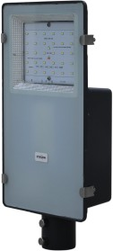










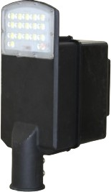
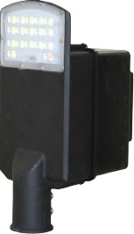
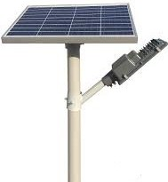
9W-120W Semi-Integrated Solar Light

Product Code | Wattage | Battery Details | Solar Panel
SMG PR009WSISSTLAH0 | 9W | 12.8V/6Ah LPF | 40W
SMG PR012WSISSTLAH0 | 12/15W | 12.8V/12Ah LPF | 50W
SMG PR020WSISSTLAH0 | 18/20W | 12.8V/18Ah LPF | 60W
SMG PR024WSISSTLAH0 | 24W | 12.8V/18Ah LPF | 80W
SMG PR030WSISSTLAH0 | 30W | 12.8V/24Ah LPF | 80W
SMG PR040WSISSTLAH0 | 36-40W | 12.8V/36Ah LPF | 100W
SMG PR050WSISSTLAH0 | 50W | 12.8V/42Ah LPF | 140W
SMG PR060WSISSTLAH0 | 60W | 12.8V/54Ah LPF | 160W
SMG PR080WSISSTLAH0 | 80W | 12.8V/72Ah LPF | 180W
SMG PR100WSISSTLAH0 | 100W | 12.8V/72Ah LPF | 200W
SMG PR120WSISSTLAH0 | 120W | 12.8V/96Ah LPF | 240W


Integrated Lights
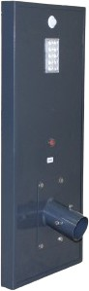
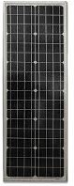
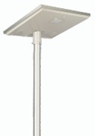
9W to 100W

Product Code | Wattage | Battery Details | Solar Panel
SMG PR09WISSTLAH000 | 9W | 12.8V/6Ah LPF | 30W
SMG PR12WISSTLAH000 | 12W | 12.8V/12Ah LPF | 40W
SMG PR15WISSTLAH000 | 15W | 12.8V/12Ah LPF | 40W
SMG PR18WISSTLAH000 | 18-20W | 12.8V/18Ah LPF | 50W
SMG PR24WISSTLAH000 | 24W | 12.8V/18Ah LPF | 60W
SMG PR30WISSTLAH000 | 30W | 12.8V/24Ah LPF | 60W
SMG PR40WISSTLAH000 | 40W | 12.8V/36Ah LPF | 80W
SMG PR50WISSTLAH000 | 50W | 12.8V/42Ah LPF | 100W
SMG PR60WISSTLAH000 | 60W | 12.8V/54Ah LPF | 120W
SMG PR80WISSTLAH000 | 80W | 12.8V/72Ah LPF | 160W
SMG PR100WISSTLAH00 | 100W | 12.8V/96Ah LPF | 200W

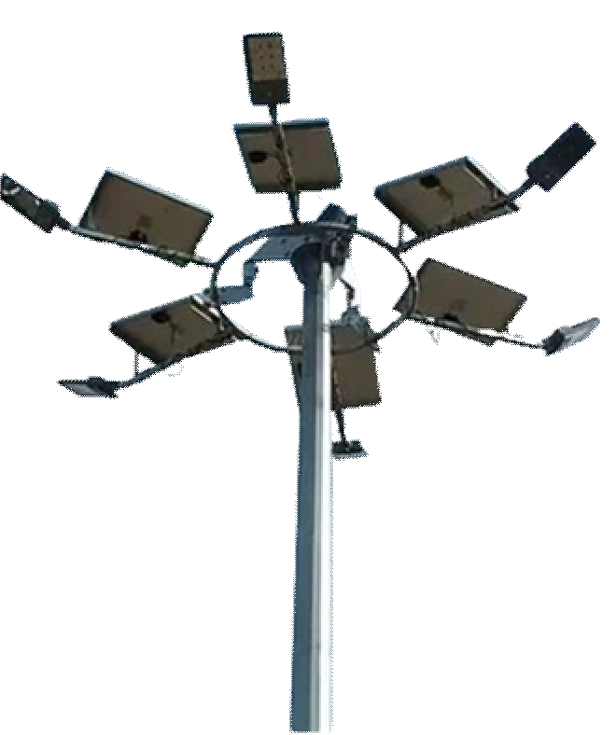






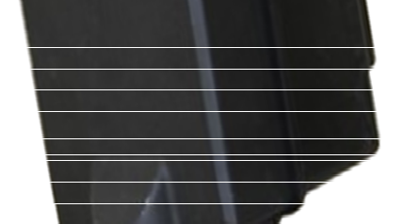



High-Mask Solar Lights



Flood Light
Street Light

Product Code | Wattage | Battery Details | Solar Panel
SMG PR090W | 90W | 25.6V/60Ah LPF | 260W
SMG PR120W | 120W | 25.6V/72Ah LPF | 300W
SMG PR150W | 75W*2 | 25.6V/84Ah LPF | 400W
SMG PR180W | 90W*2 | 25.6V/120Ah LPF | 520W
SMG PR200W | 100W*2 | 12.8V/144Ah LPF | 580W

Technical Specifications: Solar Light
- LED Light Lumens: 120/150lm/W.
- BIS Certified Battery- Yes.
- IEC Certified Solar MMPT Charge Controller- Yes.
- MNRE/BIS Approved Mono-crystalline Solar Panel-Yes.
- Charge Time: 5 to 7 Hours Good Sunshine.
- Backup Time: 2 Days autonomy.
- Easy to Install & Ready to use.
- LED Dispersion angle- 120°/145°.
- Light mounting height-4m to 8m above ground depending on LED Wattage.
- Humidity Range-0 to 95% (non-condensing).
- Temperature range-0 to 60 °C.

LED Indication | Condition
RED: Continuous On | Battery full discharged.
GREEN: LED Blink | Battery in charging mode.
GREEN: Continuous On | Battery fully charged.

- Solar Charger controller rating -5A/10A/15A/25A.
- LED Driver efficiency- >95% (Battery to Load).
- Battery Reverses Polarity Protection- Yes.
- Solar Panel Reverse Polarity Protection- Yes.
- Load Short Circuit Protection-Yes.
- Battery Low Load Disconnection Yes.
- Battery Full Cut-OFF- Yes.
- Protection Grade (IP)-65- Yes.
- Over Temperature Protection-75- Yes.
Protections:-

Hybrid Solar Inverter
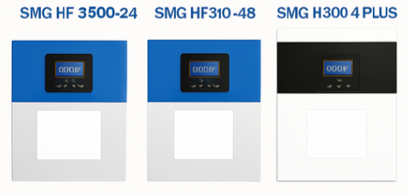

Features
Features
➢ Single-phase hybrid solar inverter.
➢ Support lithium battery charging and discharging management.
➢ Optional WI-Fl module, supports remote App monitoring.
➢ Highly integrated plug.
➢ Maximum efficiency increased 98.7%.
➢ Seamlessly enable backup power.
➢ Easy to install and maintain.
➢ Support lithium battery adaptive.
➢ 5 years warranty.
- Single-phase hybrid solar inverter.
- Support lithium battery charging and discharging management.
- Optional Wi-Fi module, supports remote App monitoring.
- Highly integrated plug.
- Maximum efficiency increased 98.7%.
- Seamlessly enable backup power.
- Easy to install and maintain.
- Support lithium battery adaptive.
- 5 years warranty.
Input Parameters
Voltage : 240V
Frequency : 50/60Hz
Efficiency : 93%
Working Temperature : -10° to 50°C Storage Temperature : -15° to 60°C Communication Interface : RS232/RS485/
CAN / Dry contact
Output Parameters
AC Stabilized Voltage : 230V AC (+/-5%) Surge Power : 7KVA/11KVA/16KVA
Switching Time : 10ms for PC / 20ms for Home appliances
Waveform : Pure sine wave

Technical Parameters

Sr.No | Model | Rated power | Max. Photo- voltaic Power | Max. PV Open Circuit Voltage | MPPT  Range & Working Voltage | Max. PV charging Current | Max. AC Charging Current
1 | SMG PR HF 3500-  24 | 3500VA  /3500W | 3500W | 500V | 120~450V DC | 100A | 60A
2 | SMG PR HF 5500-  48 | 5500VA  /5500W | 5500W | 500V | 120~450V DC | 100A | 60A
3 | SMG PR HF 8000-  48 Plus | 8000VA  /8000W | 8000W | 500V | 120~450V DC | 120A | 120A

Three Phase On-Grid Inverter Datasheet

Three Phase String Inverter

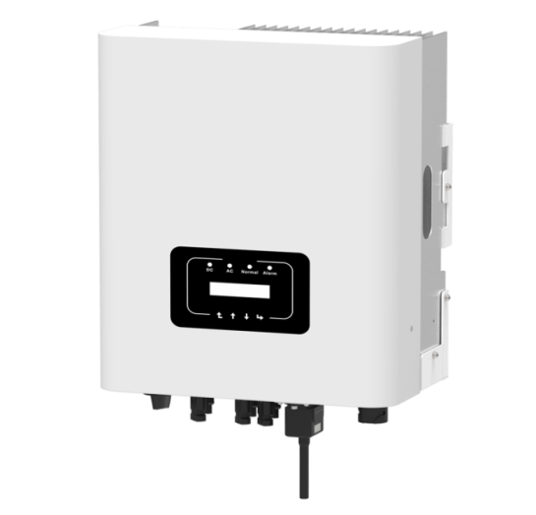
SMG 5.0K-3P | SMG 6.0K-3P | SMG 8.0K-3P | SMG 10K-3P | SMG 12K-3P
- Zero Export & VSG Application
- Low Start-Up Volatge of 80V
- Wide Output Voltage Range
- Inbuilt Wifi GPRS (Optional)
- Suited for Outdoor
- BIS Certified 10 Years Warranty
- Easy to Service
- Cloud Based Monitoring

DC Input
Parameter | SMG 5.0K-3P | SMG 6.0K-3P | SMG 8.0K-3P | SMG 10K-3P | SMG 12K-3P
Start up DC Input Voltage(V) | 140 | 250 | 250 | 250 | 250
MPPT Operating Range (v) | 120-1000 | 200-1000 | 200-1000 | 200-1000 | 200-1000
MAX. DC Input Power (KW) | 6.5 | 7.8 | 10.4 | 13 | 15.6
MAX. DC Input Voltage (v) | 1100 | 1100 | 1100 | 1100 | 1100
Max DC Input Current (A) | 20+20 | 30+30 | 30+30 | 30+30 | 30+30
Max Short Circuit Current(A) | 20+20 | 30+30 | 30+30 | 30+30 | 30+30
No. of MPP Tracker | 2 | 2 | 2 | 2 | 2
No. of strings per MPP Tracker | 1+1 | 1+1 | 1+1 | 1+1 | 1+1

AC Output
Rated Output Power (KW) | 5 | 6 | 8 | 10 | 12
Max. Active Power (kW) | 5.5 | 6.6 | 8.8 | 11 | 13.2
Rated Ac Gride Output Current | 7.6/7.2 | 9.1/8.7 | 12.1/11.6 | 15.2/14.5 | 18.2/17.4
Max. AC Output Current (A) | 8.3/8 | 10/9.6 | 13.3/12.7 | 16.7/15.9 | 20/19.1
- Rated Output Voltage/range (V): 400V AC (3P + N + E)
- Rated Grid Frequency (Hz): 50/60 (optional)
- Operating Phase: Three Phase
- Output Power Factor: 0.8 Leading to 0.8 lagging
- Total Harmonics Current Distortion (THDi): <0.3%
- DC Injection Current (mA): <0.5%
- Grid Frequency Range (Hz): 45-55

Efficiency
- Max. Efﬁciency (Inverter): 98.30%
- Euro Efﬁciency: 97.50%
- MPPT Efﬁciency: >99%

Protections
- DC Reverse - Polarity Protection
- AC Short Circuit Protection
- AC Output Overcurrent Protection
- Output Overvoltage Protection
- Insulation Resistance Protection
- Ground Fault Monitoring
- Anti-Islanding Protection
- Temprature Protection
- Integrated DC Switch
- Remorte Software Upload
- Remorte Change Operating Parameters
- Surge Protection (DC Type II / AC Type II)

Mechanical & Environmental
- Size(mm): 330W × 457H × 203D
- Colour Shade: #383636 & #716C
- Weight(kg): 11
- Topology: Transformerless
- Internal Consumption: <1W (Night)
- Operating Temperature: -25° to +60° C (derating above 45°)
- Ingress Protection: IP65
- Noise Emission (Typical): ≤30dB Natural Cooling
- Max. Operating Altitude Without Derating: 4000m
- Certiﬁcations: IEC 62116, IEC 61727, IEC60068-2-1,2,14,30,27,64, IEC 61683, IEC 61000 1/2, IEC 62109-1&2
- Humidity: 0-100% (Non Condensing)
- LCD1602
- RS485/RS232/Wiﬁ/GPRS

Three Phase String Inverter

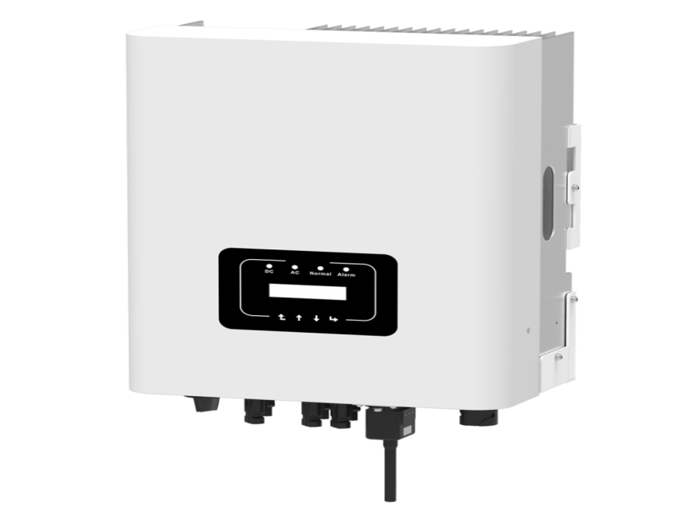

SMG 15K-3P | SMG 18K-3P | SMG 20K-3P | SMG 25K-3P
- Zero Export & VSG Application
- Low Start-Up Volatge of 80V
- Wide Output Voltage Range
- Inbuilt Wifi GPRS (Optional)
- Suited for Outdoor
- BIS Certified 10 Years Warranty
- Easy to Service
- Cloud Based Monitoring

DC Input
Parameter | SMG 15K-3P | SMG 18K-3P | SMG 20K-3P | SMG 25K-3P
MAX. DC Input Power (KW) | 19.5 | 23.4 | 26 | 32.5
MAX. DC Input Voltage (v) | 1100 | 1100 | 1100 | 1100
Start up DC Input Voltage(V) | 250 | 250 | 250 | 250
MPPT Operating Range (v) | 200-1000 | 200-1000 | 200-1000 | 200-1000
Max DC Input Current (A) | 20+26 | 26+26 | 26+26 | 26+26
Max Short Circuit Current(A) | 30+39 | 39+39 | 39+39 | 39+39
No. of MPP Tracker | 2 | 2 | 2 | 2
No. of strings per MPP Tracker | 1+2 | 2+2 | 2+2 | 2+2

AC Output
Rated Output Power (KW) | 15 | 18 | 20 | 25
Max. Active Power (kW) | 16.5 | 19.8 | 22 | 27.5
Rated Ac Gride Output Current | 22.7/21.7 | 27.3/26.1 | 30.3/29 | 37.9/36.2
Max. AC Output Current (A) | 25/23.9 | 30/28.7 | 33.3/21.9 | 41.7/39.8
- Rated Output Voltage/range (V): 400V AC (3P + N + E)
- Rated Grid Frequency (Hz): 50/60 (optional)
- Operating Phase: Three Phase
- Output Power Factor: 0.8 Leading to 0.8 lagging
- Total Harmonics Current Distortion (THDi): <0.3%
- DC Injection Current (mA): <0.5%
- Grid Frequency Range (Hz): 45-55

Efficiency
Parameter | Value
Max. Efﬁciency (Inverter) | 98.50% / 98.60%
Euro Efﬁciency | 97.50% / 97.83%
MPPT Efﬁciency | >99%

Protections
- DC Reverse - Polarity Protection
- AC Short Circuit Protection
- AC Output Overcurrent Protection
- Output Overvoltage Protection
- Insulation Resistance Protection
- Ground Fault Monitoring
- Anti-Islanding Protection
- Temprature Protection
- Integrated DC Switch
- Remorte Software Upload
- Remorte Change Operating Parameters
- Surge Protection (DC Type II / AC Type II)

Mechanical & Environmental
- Weight(kg): 15 / 20
- Size(mm): 283W × 463H × 178D / 362W × 527H × 220D
- Colour

SINGLE PHASE ON-GRID INVERTER DATASHEET
SMG 1.5K-1P | SMG 2.2K-1P | SMG 3.0K-1P | SMG 4.0K-1P | SMG 5.0K-1P | SMG 6.0K-1P
- BIS Certified – 10 Years Warranty
- Easy to Service
- Cloud Based Monitoring
- Zero Export & VSG Application
- Low Start-Up Voltage of 80V
- 20A String Current
- Suited for Outdoor
- Wide Output Voltage Range
- Inbuilt Wifi GPRS (Optional)

Technical Data

Input Side
MODEL | SMG 1.5K-1P | SMG 2.2K-1P | SMG 3.0K-1P | SMG 4.0K-1P | SMG 5.0K-1P | SMG 6.0K-1P
MAX. DC Input Power (KW) | 2 | 2.9 | 3.9 | 5.2 | 6.5 | 7.8
MAX. DC Input Voltage (V) |  |  | 550
Start up DC Input Voltage (V) |  |  | 80
MPPT Operating Range (V) |  |  | 70-500 | 70-500
MAX DC Input Current (A) |  |  | 20 | 20
MAX Short Circuit Current (A) |  |  | 30
No. Of MPP Tracker |  |  | 1
No. strings per MPP Tracker |  | 1 |  |  | 2 | 2

Output Side
MODEL | SMG 1.5K-1P | SMG 2.2K-1P | SMG 3.0K-1P | SMG 4.0K-1P | SMG 5.0K-1P | SMG 6.0K-1P
Rated Output Power (KW) | 1.5 | 2.2 | 3 | 4 | 5 | 6
MAX. Active Power (KW) | 1.65 | 2.42 | 3.3 | 4.4 | 5.5 | 6.6
Rated Output Voltage/range (V) |  |  | 230V AC (L+N+E)
Rated Grid Frequency (Hz) | 50/60 (Optional) | 50/60 (Optional) | 50/60 (Optional) | 50/60 (Optional)
Operating Phase |  |  | Single Phase | Single Phase
Rated Ac Gride Output Current | 6.5 | 9.6 | 13 | 17.4 | 22.8/21.8 | 27.3/26.1
Max. AC Output Current (A) | 7.2 | 10.5 | 14.3 | 19.1 | 25/24 | 30/28.7
Output Power Factor |  |  | 0.8 leading to 0.8 lagging
THDi
DC Injection Current (mA)
Grid Frequency Range (Hz) |  |  | 45-55

Efficiency
MODEL | SMG 1.5K-1P | SMG 2.2K-1P | SMG 3.0K-1P | SMG 4.0K-1P | SMG 5.0K-1P | SMG 6.0K-1P
Max. Efficiency (Inverter) | 97.30% | 97.30% | 97.50% | 97.50% | 97.50% | 97.50%
Euro Efficiency | 97.10% | 97.10% | 97.30% | 97.30% |  | 97.00%
MPPT Efficiency |  |  | >99%

Protections
- DC Reverse Polarity Protection
- AC Short Circuit Protection
- AC Output Overcurrent Protection
- Output Overvoltage Protection
- Insulation Resistance Protection
- Ground Fault Monitoring
- Anti-Islanding Protection
- Temprature Protection
- Integrated DC Switch
- Remorte Software Upload
- Remorte Change Operating Parameters
- Surge Protection (DC Type II / AC Type II)

General Data
Parameter | Value
Size (mm) | 280W×310H×184D (SMG 1.5–3.0K) / 330W×323H×190D (SMG 4.0–6.0K)
Colour Shade | 383636 & 716C
Weight (kg) | 4.8 (SMG 2.2K) / 7.7 (SMG 5.0K)
Topology | Transformerless
Internal Consumption
Operating Temperature | –25℃ to +60℃ (derating above 45°)
Ingress Protection | IP65
Noise Emission (Typical) | ≤35dB
Cooling Type | Natural Cooling
Max. Operating Altitude Without Derating | 2000m (SMG 2.2K) / 3000m (SMG 5.0K)
Certifications | IEC 62116, IEC 61727, IEC60068-2-1,2,14,30,27,64, IEC 61683, IEC 61000 1/2, IEC 62109-1&2
Humidity | 0–100% (Non Condensing)
Display | LCD1602
Interface | RS485 / RS232 / Wifi / GPRS

- 25/2, R.K.Layout, 16Th Main ,5Th Cross, R.K layout,Padmanabhanagar-Bangalore -560070,
 https://www.smgpowersolution.com


smgpowersolution@zohomail.in
+91 7892903806, +91 7204523401

